**Practical Assignment - V**

**Program :** B.Tech. (*Information Technology and Mathematical Innovations)*

**Department :** Cluster Innovation Centre, University of Delhi

**Semester :** Vth

**Title of Paper :** Algorithms for Computational Mathematics: Numerical Methods

**Name of Student :** Ashutosh Jha

**Roll No. of Student :** 11811

**Date of Submission :** Oct 05, 2020

***Ques. 1:*** Find the polynomial interpolating the points

| ***x*** | 1 | 1.3 | 1.6 | 1.9 | 2.2 |
| --- | --- | --- | --- | --- | --- |
| ***f(x)*** | 0.1411 | -0.6878 | -0.9962 | -0.5507 | 0.3115 |

where *f(x) = sin(3x)*. Compare interpolating polynomials with f(x) (using graph).

***Sol. 1:***

**Program (using C):**

#include<stdio.h>

#include<conio.h>

double interpolate(double x[], double y[], double xi, int n)

{

double result = 0;

int i;

**for** (i = 0; i <= n; i++)

{

double term = y[i];

int j;

**for** (j = 0; j < n; j++)

{

**if** (j != i)

term = term * (xi - x[j]) /

(x[i] - x[j]);

}

result += term;

}

**return** result;

}

void main()

{

double x[5] = {1, 1.3, 1.6, 1.9, 2.2};

double y[5] = {0.1411, -0.6878, -0.9962, -0.5507, 0.3115};

double k;

**for** (k = 0; k <= 2; k=k+0.1)

{

printf("%f, %f **\n**",k , interpolate(x, y, k, 5));

}

}

**Graph for *f(x) = sin(3x)*:**

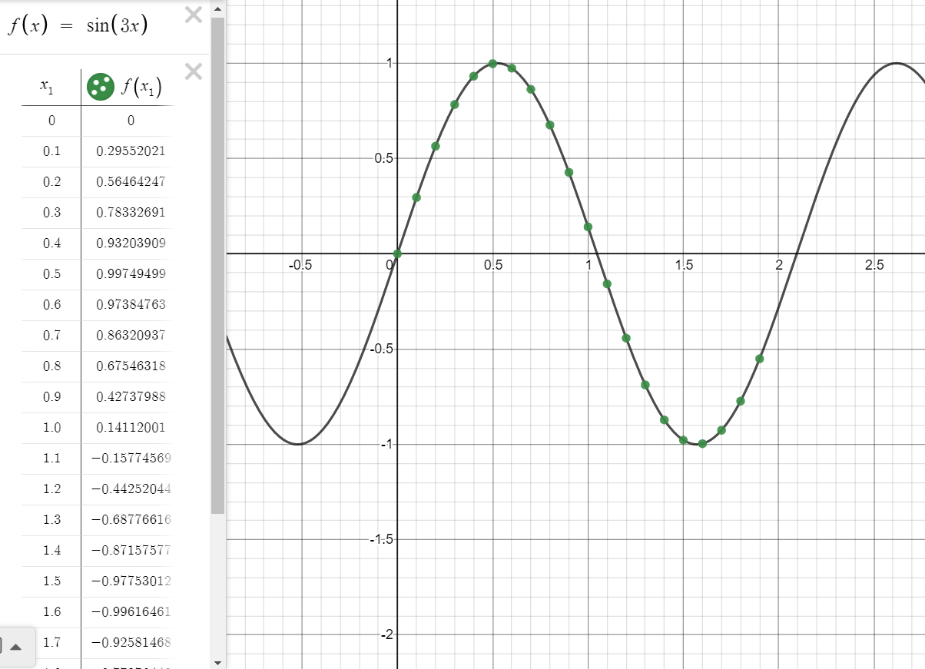

We obtain *f(x) = -2.93519 x4 + 18.4648 x3 - 39.0942 x2 + 31.693 x - 7.93333*

**Observation Table:**

| ***x*** | ***sin(3x)*** | ***f(x)*** |
| --- | --- | --- |
| 0 | 0 | -7.933326 |
| 0.1 | 0.29552021 | -5.1422 |
| 0.2 | 0.56464247 | -3.026278 |
| 0.3 | 0.78332691 | -1.485337 |
| 0.4 | 0.93203909 | -0.4262 |
| 0.5 | 0.99749499 | 0.237267 |
| 0.6 | 0.97384763 | 0.584152 |
| 0.7 | 0.86320937 | 0.6865 |
| 0.8 | 0.67546318 | 0.609311 |
| 0.9 | 0.42737988 | 0.410541 |
| 1 | 0.14112001 | 0.1411 |
| 1.1 | -0.15774569 | -0.155144 |
| 1.2 | -0.44252044 | -0.44137 |
| 1.3 | -0.68776616 | -0.6878 |
| 1.4 | -0.87157577 | -0.8717 |
| 1.5 | -0.97753012 | -0.977381 |
| 1.6 | -0.99616461 | -0.9962 |
| 1.7 | -0.92581468 | -0.926556 |
| 1.8 | -0.77276449 | -0.773893 |
| 1.9 | -0.55068554 | -0.5507 |

**Graph for *f(x) = -2.93519 x4 + 18.4648 x3 - 39.0942 x2 + 31.693 x - 7.93333*:**

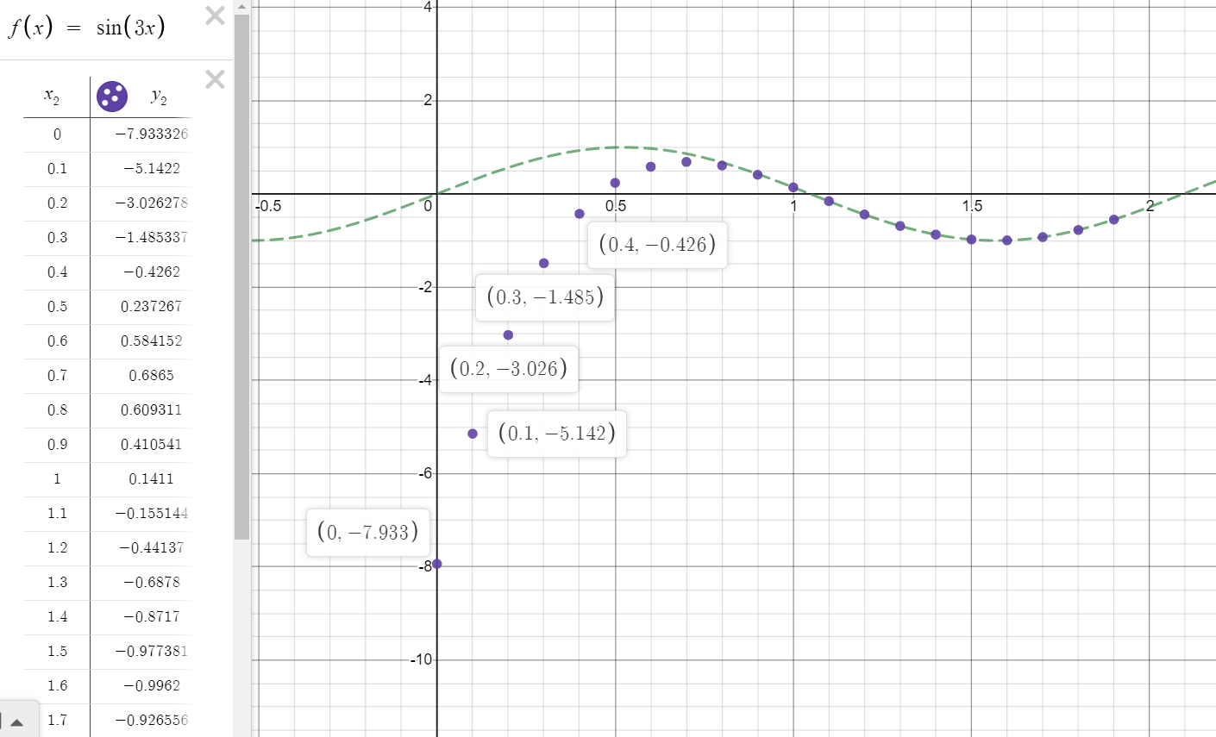

**Conclusion:** Before, x = 1, the interpolated polynomial formed shows a divergence effect i.e. error from function sin(3x) keeps on increasing as we decrease the value of x. On the other hand, after x = 1, the graph seems to show the trend similar to sin(3x).

***Ques. 2:*** For functions *f(x) = cos(x)* and *f(x) = $\frac{1}{1+x^{2}}$* , find the interpolating polynomial through a set

of equidistant points in the interval *[-5, 5]*.

Find the interpolating polynomial for *n = 6* and then for *n = 11* and compare both these graphs with *f(x)*. (n= number of points).

And write a short note for your error analysis.

***Sol. 2:***

For *f(x) = cos(x)* and *n = 6*

**Program (using C):**

#include<stdio.h>

#include<conio.h>

double interpolate(double x[], double y[], double xi, int n)

{

double result = 0;

int i;

**for** (i = 0; i <= n; i++)

{

double term = y[i];

int j;

**for** (j = 0; j < n; j++)

{

**if** (j != i)

term = term * (xi - x[j]) /

(x[i] - x[j]);

}

result += term;

}

**return** result;

}

void main()

{

double x[5] = {1, 1.3, 1.6, 1.9, 2.2};

double y[5] = {0.1411, -0.6878, -0.9962, -0.5507, 0.3115};

double k;

**for** (k = 0; k <= 2; k=k+0.1)

{

printf("%f, %f **\n**",k , interpolate(x, y, k, 5));

}

}

For *f(x) = cos(x)* and *n = 11*

**Program (using C):**

#include<stdio.h>

#include<conio.h>

double interpolate(double x[], double y[], double xi, int n)

{

double result = 0;

int i;

**for** (i = 0; i <= n; i++)

{

double term = y[i];

int j;

**for** (j = 0; j < n; j++)

{

**if** (j != i)

term = term * (xi - x[j]) /

(x[i] - x[j]);

}

result += term;

}

**return** result;

}

int main()

{

double x[11] = {-5, -4, -3, -2, -1, 0, 1, 2, 3, 4, 5};

double y[11] = {0.2836, -0.6536, -0.9899, -0.4161, 0.5403, 1, 0.5403, -0.4161, -0.9899, -0.6536, 0.2836};

double k;

**for** (k = -10; k <= 10; k++)

{

printf("%f, %f **\n**",k , interpolate(x, y, k, 11));

}

}

***f(x) {for n=6}:*** -8.789 * 10-8 *x*5 + 0.0113 *x*4 + 2.285 x 10-6 *x*3 - 0.3041 *x*2 - 2.197x10-6 *x* + 0.833

***g(x) {for n=11}:*** *-1.432 * 10-11 x10 - 1.242 * 10-21 x9 + 7.771 * 10-10 x8 + 1.240 * 10-19 x7 - 1.432 * 10-8 x6 - 2.507 * 10-18 x5 + 0.112 x4 + 0 x3 - 0.304 x2 + 1.665 *10-16 x + 0.833*

| ***x*** | ***cos(x)*** | ***f(x) for n = 6*** | ***g(x) for n = 11*** |
| --- | --- | --- | --- |
| -10 | -0.83907 | 83.281432 | 83.2026 |
| -9 | -0.911130 | 50.2468 | 50.2234 |
| -8 | -0.1455 | 27.596651 | 27.591 |
| -7 | 0.7539 | 13.0286 | 13.0276 |
| -6 | 0.96017 | 4.511132 | 4.51103 |
| -5 | 0.28366 | 0.2836 | 0.2836 |
| -4 | -0.6536 | -1.143774 | -1.14377 |
| -3 | -0.9899 | -0.9899 | -0.9899 |
| -2 | -0.4161 | -0.202818 | -0.202818 |
| -1 | 0.5403 | 0.5403 | 0.5403 |
| 0 | 1 | 0.833151 | 0.833151 |
| 1 | 0.5403 | 0.5403 | -0.5403 |
| 2 | -0.4161 | -0.202818 | -202818 |
| 3 | -0.9899 | -0.9899 | -0.9899 |
| 4 | -0.6536 | -1.143774 | -1.14377 |
| 5 | 0.25366 | 0.2836 | 0.2836 |
| 6 | 0.96017 | 4.511132 | 4.51103 |
| 7 | 0.75390 | 13.0286 | 13.0276 |
| 8 | -0.1455 | 27.596651 | 27.591 |
| 9 | -0.9111 | 50.2468 | 50.2234 |
| 10 | -0.8390 | 83.281432 | 83.2026 |

**Graph for *f(x)* for *n = 6***

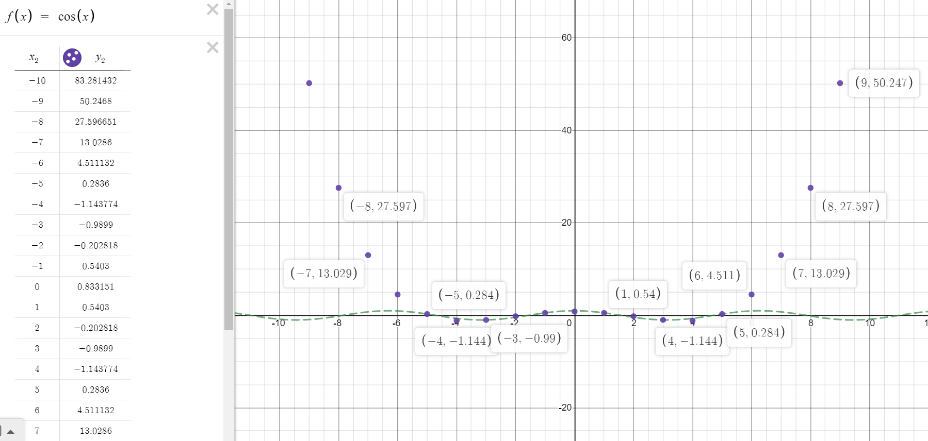

The graph shows a similar trend as *cos x* in the range [-5,5] but outside that range, it increases exponentially as we go away from the origin.

**Graph for *g(x) for* *n = 11:***

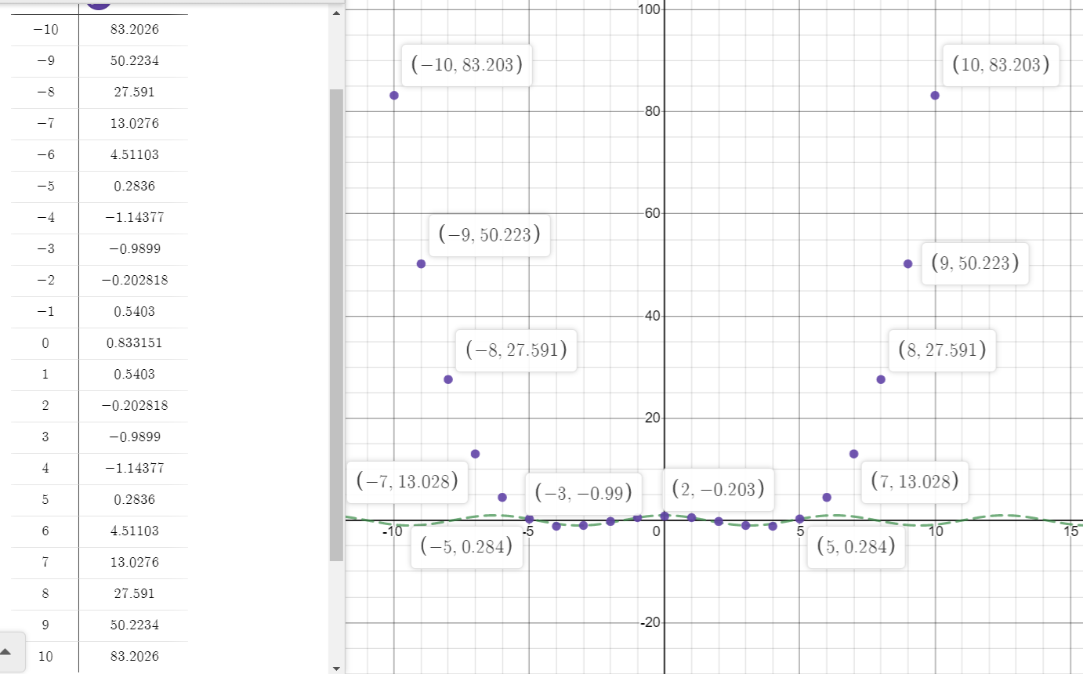

The graph shows a similar trend as *cos x* in the range [-5,5] but outside that range, it increases exponentially as we go away from the origin.

For *f(x) = $\frac{1}{1+x^{2}}$*  and *n = 6*

**Program (using C):**

#include<stdio.h>

#include<conio.h>

double interpolate(double x[], double y[], double xi, int n)

{

double result = 0;

int i;

**for** (i = 0; i <= n; i++)

{

double term = y[i];

int j;

**for** (j = 0; j < n; j++)

{

**if** (j != i)

term = term * (xi - x[j]) /

(x[i] - x[j]);

}

result += term;

}

**return** result;

}

int main()

{

double x[6] = {-5, -3, -1, 1, 3, 5};

double y[6] = {0.03846, 0.1, 0.5, 0.5, 0.1, 0.03846};

double k;

**for** (k = -10; k <= 10; k++)

{

printf("%f, %f **\n**",k , interpolate(x, y, k, 6));

}

}

For *f(x) = $\frac{1}{1+x^{2}}$*  and *n = 11*

**Program (using C):**

#include<stdio.h>

#include<conio.h>

double interpolate(double x[], double y[], double xi, int n)

{

double result = 0;

int i;

**for** (i = 0; i <= n; i++)

{

double term = y[i];

int j;

**for** (j = 0; j < n; j++)

{

**if** (j != i)

term = term * (xi - x[j]) /

(x[i] - x[j]);

}

result += term;

}

**return** result;

}

int main()

{

double x[11] = {-5, -4, -3, -2, -1, 0, 1, 2, 3, 4, 5};

double y[11] = {0.03846, 0.0588, 0.1, 0.2, 0.5, 1, 0.5, 0.2, 0.1, 0.0588, 0.03846};

double k;

**for** (k = -10; k <= 10; k++)

{

printf("%f, %f **\n**",k , interpolate(x, y, k, 11));

}

}

***f(x) {for n=6}:*** 0\**x*5 + 0.001923*x*4 + 0\**x*3 - 0.06923*x*2 + 0\**x* + 0.567308

***g(x) {for n = 11}:*** *-0.0000226 x 10 + 0 x9 + 0.00126 x8 + 0 x7 - 0.024 x6 + 0 x5 + 0.197 x4 + 0 x3 - 0.674 x2 - 5.551 * 10-17 x + 1*

| ***x*** | ***f(x) =*** | ***f(x) for n = 6*** | ***f(x) for n = 11*** |
| --- | --- | --- | --- |
| -10 | 0.00990 | 12.874964 | -122051 |
| -9 | 0.0121 | 7.5769 | -36079.5 |
| -8 | 0.01538 | 4.013448 | -8669.63 |
| -7 | 0.02 | 1.7923 | -1517.17 |
| -6 | 0.02702 | 0.567304 | -146.419 |
| -5 | 0.03846 | 0.03846 | 0.03846 |
| -4 | 0.058823 | -0.048077 | 0.0588 |
| -3 | 0.1 | 0.1 | 0.1 |
| -2 | 0.2 | 0.321154 | 0.2 |
| -1 | 0.5 | 0.5 | 0.5 |
| 0 | 1 | 0.567308 | 1 |
| 1 | 0.5 | 0.5 | 0.5 |
| 2 | 0.2 | 0.321154 | 0.2 |
| 3 | 0.1 | 0.1 | 0.1 |
| 4 | 0.058823 | -0.048077 | 0.0588 |
| 5 | 0.03846 | 0.03846 | 0.03846 |
| 6 | 0.02702 | 0.567304 | -146.419 |
| 7 | 0.02 | 1.7923 | -1517.17 |
| 8 | 0.0153846 | 4.013448 | -8669.63 |
| 9 | 0.01219 | 7.5769 | -36079.5 |
| 10 | 0.00990 | 12.874964 | -122051 |

**Graph for *f(x)*  for *n = 6:***

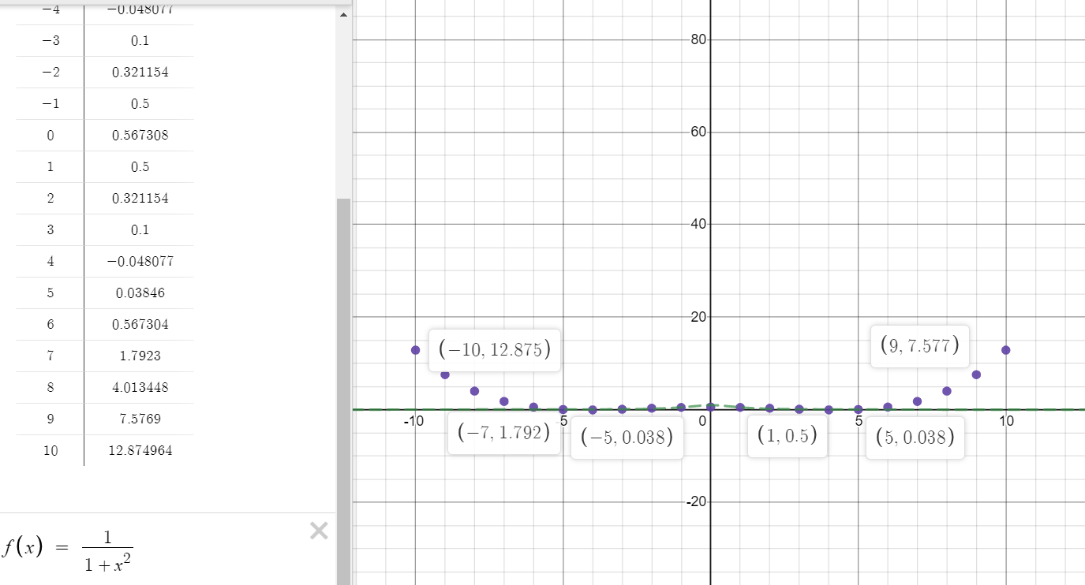

**Conclusion:** In the above graph, the f(x) function shows a similar trend as  *1/1+x2* in the range of [-5,5] but outside that range, the graph diverges and error increases continuously as the we go away from the origin.

**Graph for *g(x)* for *n = 11:***

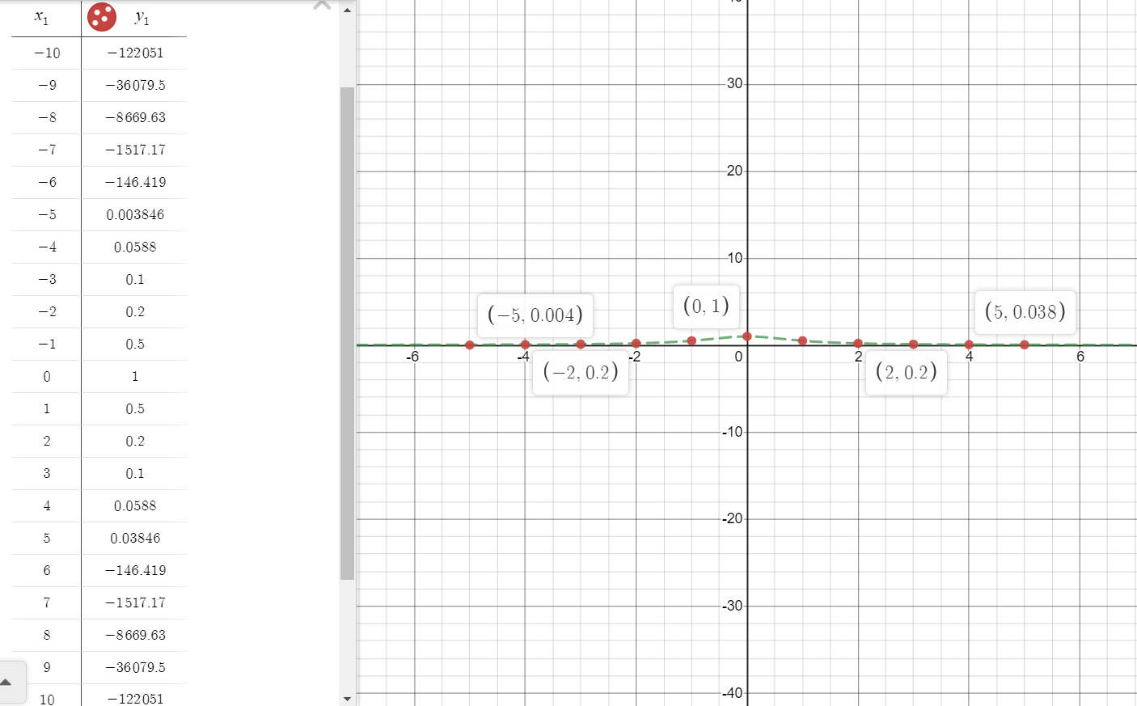

**Conclusion:** In the above the graph, the plot follows a similar trend as the original function *1/1+x2* in the range of [-5,5] but continues to diverge as we go away from the origin.

**Combined graph for *f(x) and g(x)* for *n = 6, 11 respectively:***

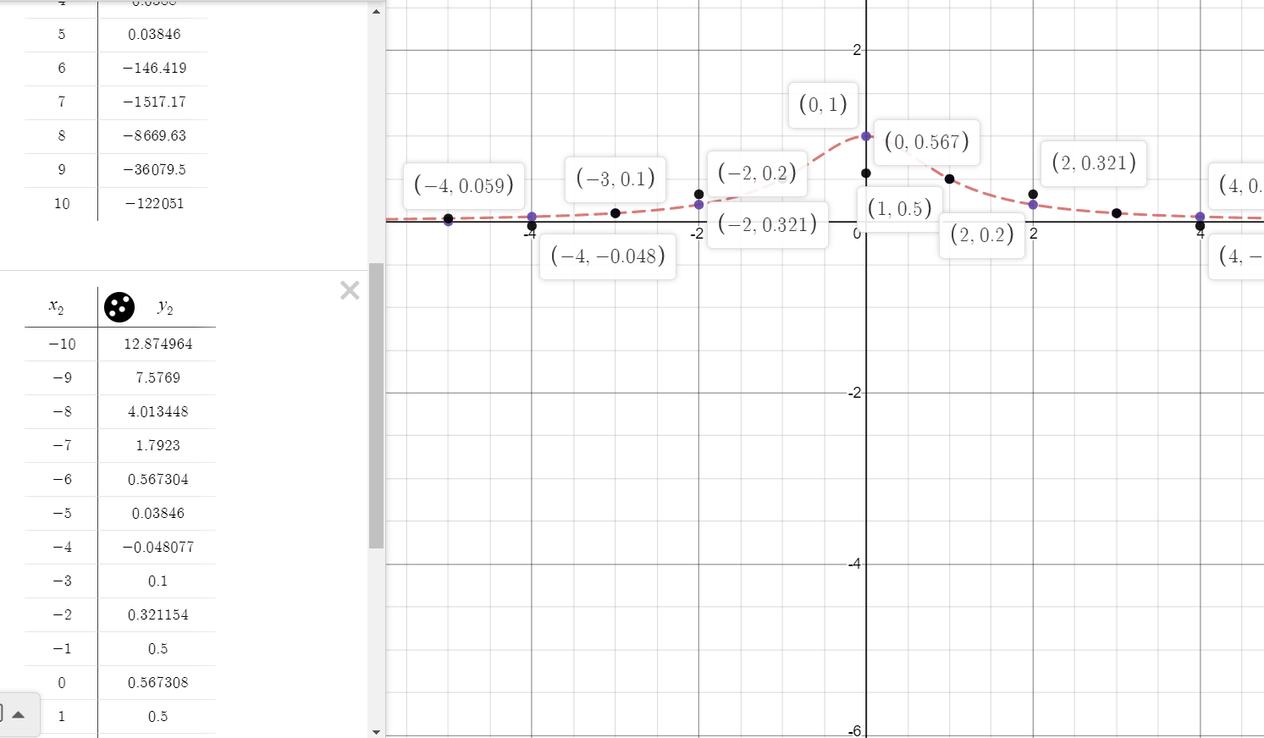

**Conclusion:** In the above graph, the blue dots are of g(x) {for n=11} and black dots are of f(x){for n=6}.

Both the graphs show almost similar trend in the range [-5,5] but outside that range, f(x) continues to increase i.e. error increases while g(x) continues to decrease i.e. negative error increases as one goes away from the origin.